Transportation Log Instructions
(Printing this page is highly recommended!)
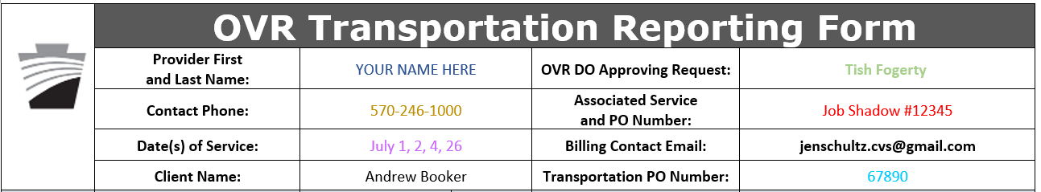
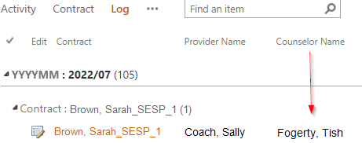
- Provider First and Last Name: Your first and last name.
- OVR DO Approving Request: The OVR Counselor’s name. You can find this under the Counselor Name column in SharePoint.

- Contact Phone: Your phone number

- Associated Service and PO Number: List the service and PO Number associated with this contract. Some Job Shadows, PWEs and WEXA services will have an associated transportation contract. In this sample, Andrew Booker is being transported to his Job Shadow. That Job Shadow’s PO Number is: 12345. You can find this in SharePoint Log View under the “Contract:PO Number” column and on the calendar for your day of service with the client.

- Date(s) of Service: List each day you provided transportation. Also list these dates in the left column of the signature section.

- Billing contact email: Pre-filled for you.
- Client name: The first and last name of your client.
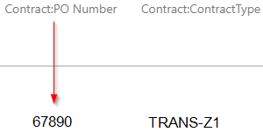
- Transportation PO Number: This is either the Pre-ETS Referral ID or the ‘Paper’ Purchase Order #. This can be found in SharePoint Log view in the Contract: PO Number column for this Transportation contract. Please reach out if you are having trouble finding this number. This should also be found on your calendar on the day you transported. The CVS OVR admin (Alison) will type it in there for you.

NOTES ABOUT THE SIGNATURE SECTION
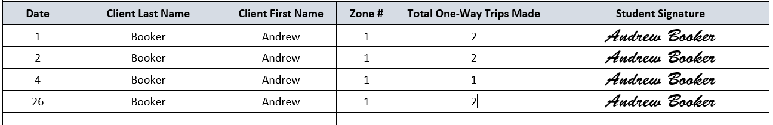
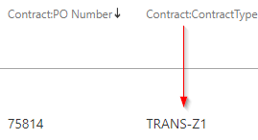
- Each line is for a single date of service.
- Make certain you are entering the correct Zone Type for the contract. You can find this under the contract name in SharePoint. “TRANS-Z1” is Zone 1. “TRANS-Z2” is Zone 2. Look for the number that comes after the Z.
- Only enter the number of one-way trips you made on that date. (On a single day, if you transported one-way to the site and transported one-way from the site, that counts as 2 one-way trips. You would then place a 2 in the box for that date. Do not record your hours or the time spent driving. It’s 1 unit per one-way trip.)

ENTERING TRANSPORTATION TRIPS INTO SHAREPOINT
Transportation is tracked by the number of one-way trips and not by the hours spent transporting. The SharePoint Activity input form, however, is only set up to accept times and hours. Examine the workaround for this situation below.
EX: A job coach does 2 trips in one day. They must enter the correct date and any two times in “Time in” and “Time out” as long as those two times are two hours apart. See below.
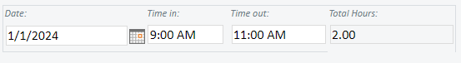
Next, they need to add a 2 to the “Transporting customer to job site (provider only:)” section in the Services Provided section below.

